Test Case: tc002_SPX_Dev5_Crear_Requisicion_Spot_Tipo_Cobro_Project
Step 1 - Enter username and password and click to button Enter: Credentials Entered
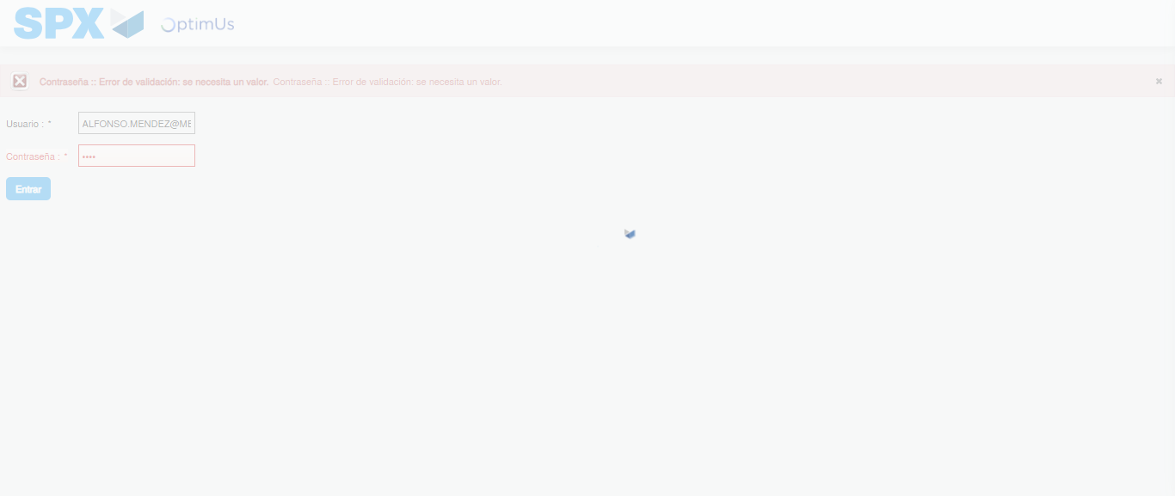Image file-name: QC_Testing-tc002_SPX_Dev5_Crear_Requisicion_Spot_Tipo_Cobro_Project-1783381872761

Step 2 - Select to UEN and Access to Spot Buy Requisitions : UEN Correctly selected and Correct access
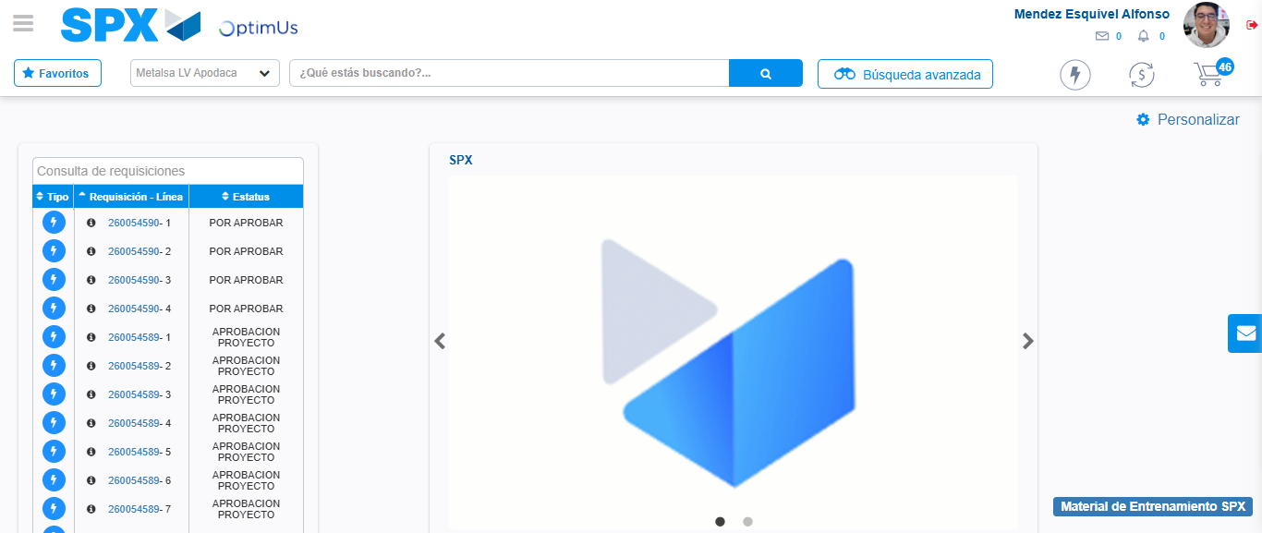Image file-name: QC_Testing-tc002_SPX_Dev5_Crear_Requisicion_Spot_Tipo_Cobro_Project-1783381898276

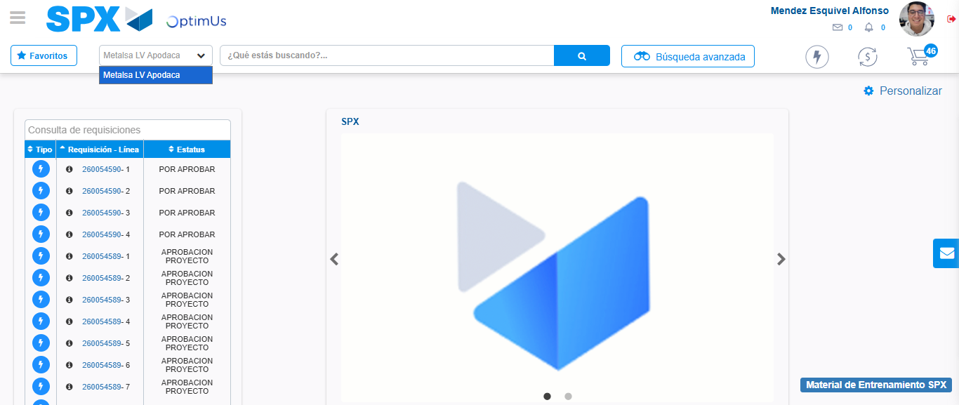Image file-name: QC_Testing-tc002_SPX_Dev5_Crear_Requisicion_Spot_Tipo_Cobro_Project-1783381900788

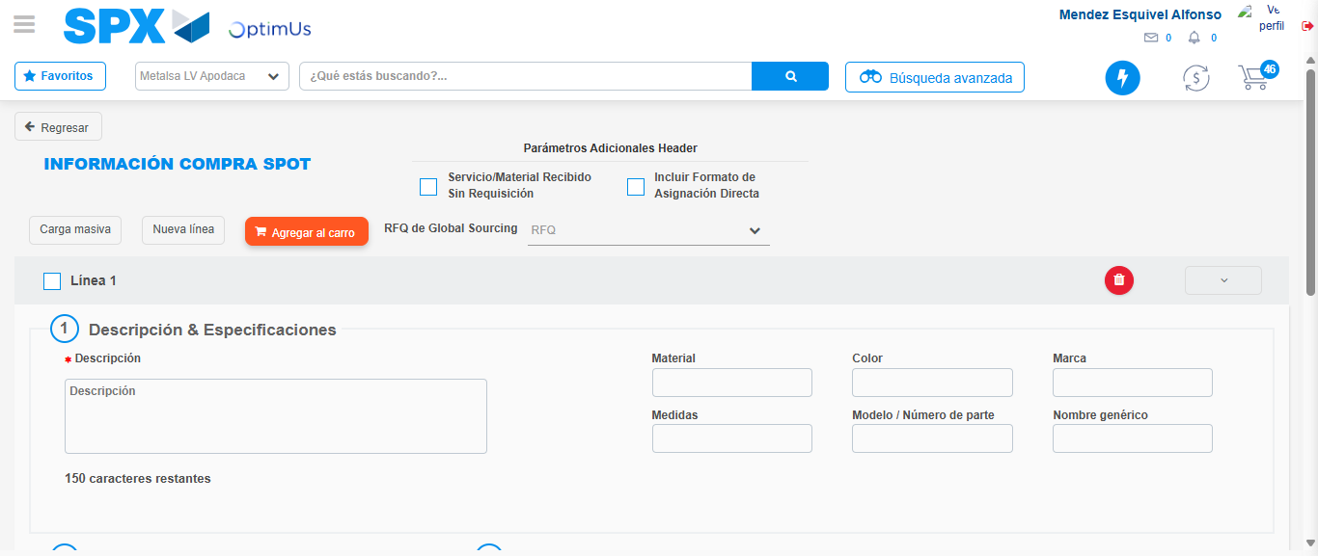Image file-name: QC_Testing-tc002_SPX_Dev5_Crear_Requisicion_Spot_Tipo_Cobro_Project-1783381925604

Step 3 - Data Capture Spot Buy Requisition: Data captured correctly
Image file-name: QC_Testing-tc002_SPX_Dev5_Crear_Requisicion_Spot_Tipo_Cobro_Project-1783381925800

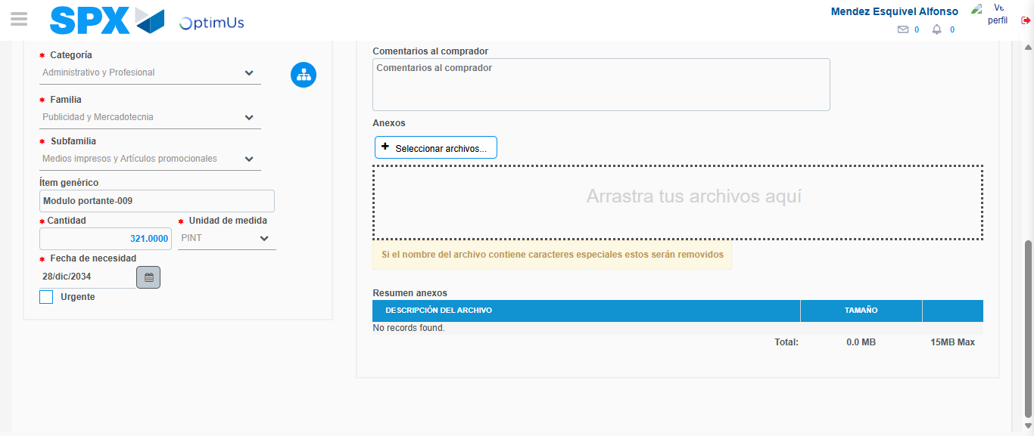Image file-name: QC_Testing-tc002_SPX_Dev5_Crear_Requisicion_Spot_Tipo_Cobro_Project-1783381935714

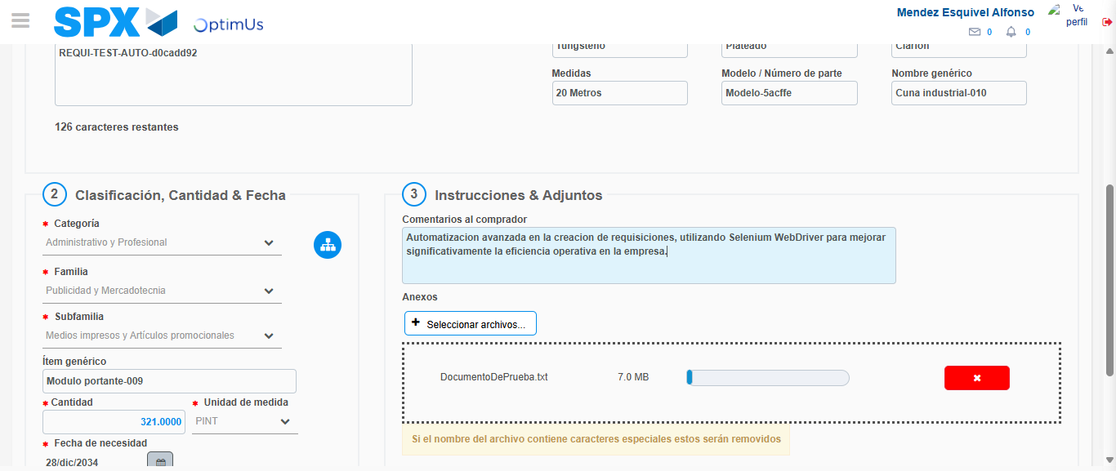Image file-name: QC_Testing-tc002_SPX_Dev5_Crear_Requisicion_Spot_Tipo_Cobro_Project-1783381936459

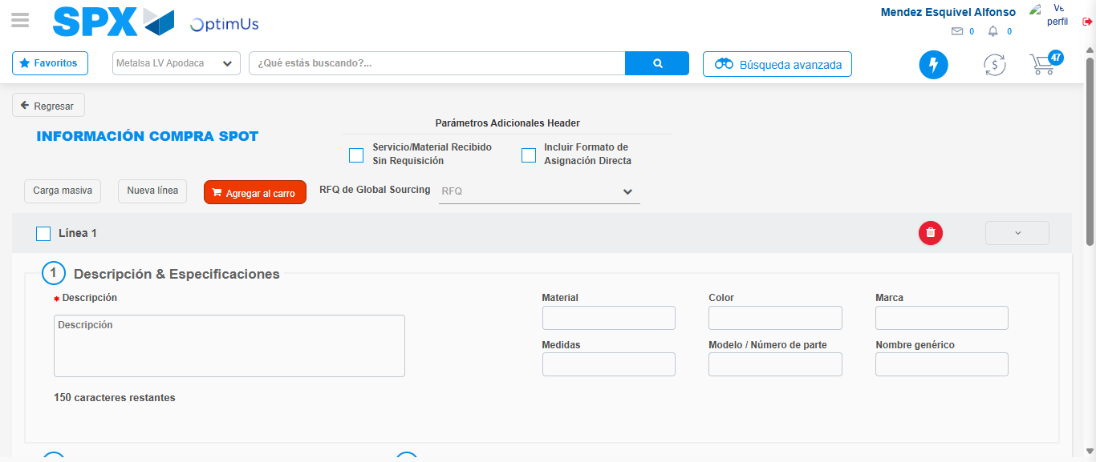Image file-name: QC_Testing-tc002_SPX_Dev5_Crear_Requisicion_Spot_Tipo_Cobro_Project-1783381948663

Step 7 - Return to Main Page SPX : Return to Main Page SPX
Image file-name: QC_Testing-tc002_SPX_Dev5_Crear_Requisicion_Spot_Tipo_Cobro_Project-1783381898276

Image file-name: QC_Testing-tc002_SPX_Dev5_Crear_Requisicion_Spot_Tipo_Cobro_Project-1783381900788

Image file-name: QC_Testing-tc002_SPX_Dev5_Crear_Requisicion_Spot_Tipo_Cobro_Project-1783381925604

Image file-name: QC_Testing-tc002_SPX_Dev5_Crear_Requisicion_Spot_Tipo_Cobro_Project-1783381950952

Image file-name: QC_Testing-tc002_SPX_Dev5_Crear_Requisicion_Spot_Tipo_Cobro_Project-1783381951115

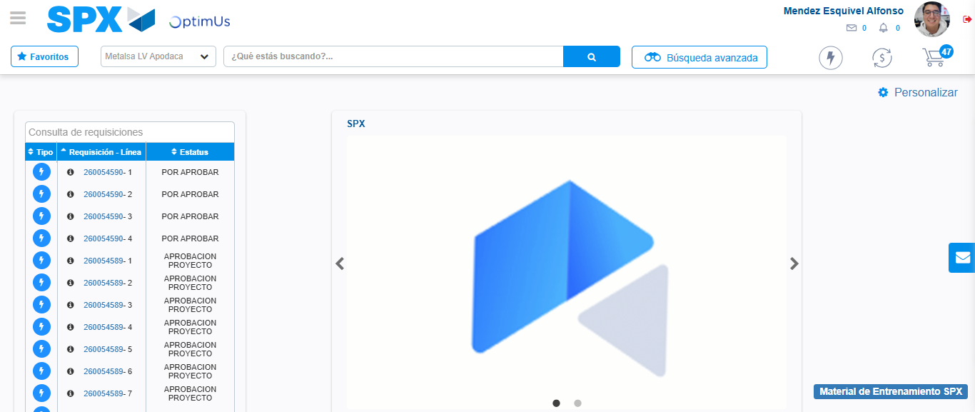Image file-name: QC_Testing-tc002_SPX_Dev5_Crear_Requisicion_Spot_Tipo_Cobro_Project-1783381972257

Step 8 - Log Out : Log Out SPX
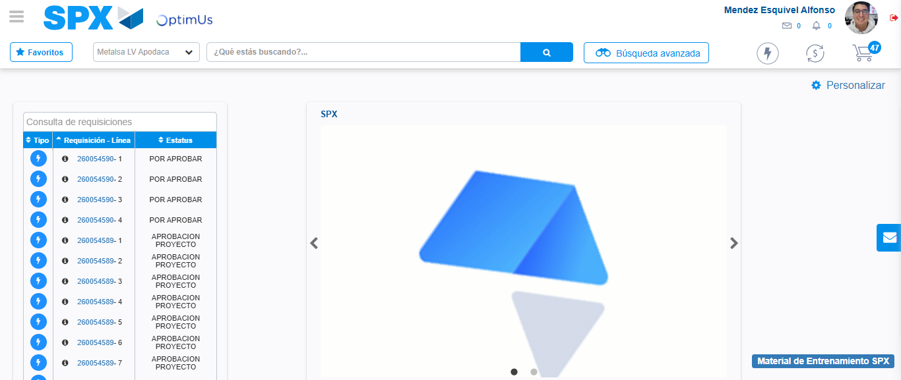Image file-name: QC_Testing-tc002_SPX_Dev5_Crear_Requisicion_Spot_Tipo_Cobro_Project-1783381972507

